**NETWORK**

**&**

**INTERNET**

BASIC COMPUTER USAGE

**OBJECTIVES FOR TODAY** 

# ✓ What is Internet ✓ What is a web site, a web page ✓ What is a Web Browser ✓ What is a Web Address

EXPLORE

## **USA Cambodia**

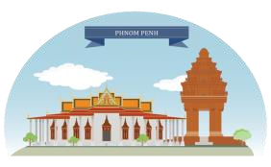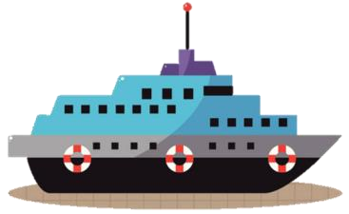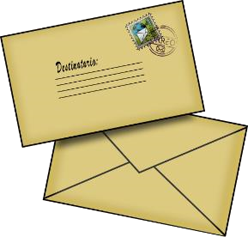

Weeks or months



5

MIN

**Before**

**Now**

 3 

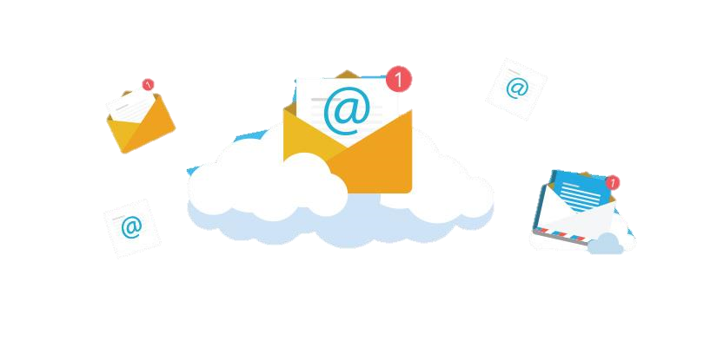

**Internet**

**Cambodia** A few seconds **USA**

EXPLORE

5 MIN  **WHAT IS …?**



|  |  |  |
| --- | --- | --- |
| |  | | --- | | **Internet** | |  |



✓

What is an

**Internet**

?

WATCH & THINK



10

MIN

Watch the video and answer the questions

# EXPLAIN Network VS Internet

10 MIN

A **computer network** is a connection between two or more computers to allow to

**exchange files** or **information** between the **computers**

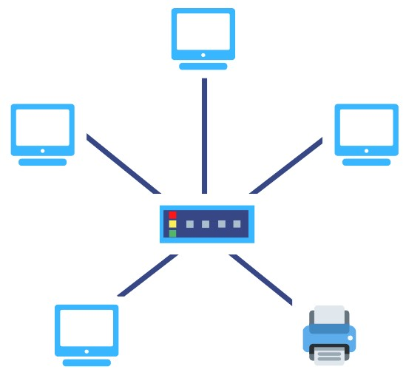

**The Internet**: sometimes called simply "the Net," is a worldwide system of **computer networks**



**NetworkInternet**

DISCUSS



2 3

5 MIN

**Why do we need the Internet?**



EXPLAIN

10 MIN  **What is a Web browser?**

**A web browser** is a software application that help you to **access** and **view websites** on the **internet**.

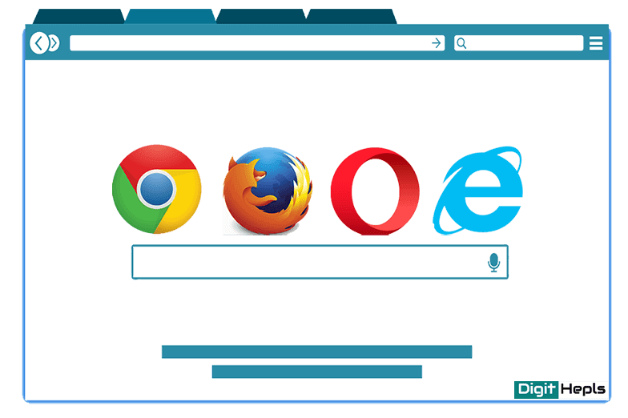

EXPLAIN

# 10 MIN Website VS. Webpage



**A webpage:** a **single document A website:** a **collection** of which contains text, images, many **webpages** which are video, audio, and other media.grouped together that belong

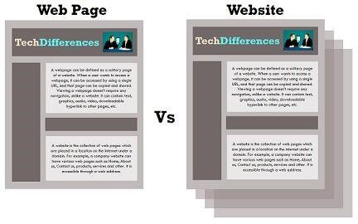

to one **domain** or owner.

* **Website** is a book.
* **Webpage** is a page in a book

DEMO



5 MIN



**Access to**:

* **Website:** [www.passerellesnumeriques.org/en/](http://www.passerellesnumeriques.org/en/)
* **Webpage:** [www.passerellesnumeriques.org/en/our-actions/cambodia/](http://www.passerellesnumeriques.org/en/our-actions/cambodia/)

ACTIVITY

# 5 MIN Activity 1



1. Open the **Web browser**

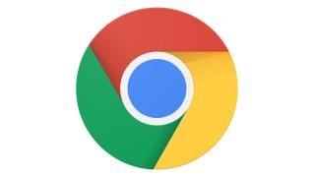

1. Access to the website [www.w3schools.com](http://www.w3schools.com/) 3. Access to other web pages keywords: **Homepage**, **Menu**

EXPLAIN

10 MIN **What is a website address?**



**A website address** refers to the name that points to a location where the website is hosted over the internet. It is also known as the **URL** (uniform resource locator).

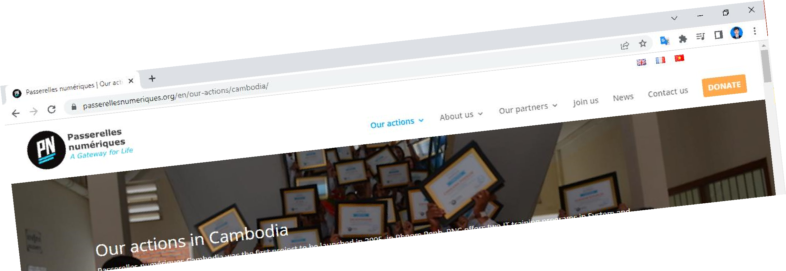

* Our PN’s **website address** is: http://www.passerellesnumeriques.org/
* Our school **webpage address** is: <https://www.passerellesnumeriques.org/en/our-actions/cambodia/>

EXPLAIN

# 10 MIN Website address | URL Structure



**https**://**www**.**passerellesnumeriques**.**org**

**Domain name**

✓**Prefix (http)** – an internet application **protocol** of your domain.

✓**Subdomain (www)** – the **third level domain** of your website name (some sites use, some not).

✓**Name (example)** – the **second-level domain** of the website, picked by the person registering the domain.

✓**Extension (.com)** – the **top-level domain** can be picked for the variety of available choices.

ENGAGE

# 5 MIN Types of Top Level Domain (TLD)



**Top level Domain:**

* **.com** for commercial
* **.edu** for education (USA)
* **.org** for organization
* **.mil** for military (USA)
* **.gov** for government (USA)
* **.net** for network provider
* …

**Country code:**

* **.us** USA
* **.kh** Khmer
* **.fr** French
* **.sg** Singapore
* **.uk** United Kingdom
* **.cn** China
* …

EXPLAIN

# 10 MIN Search Engine

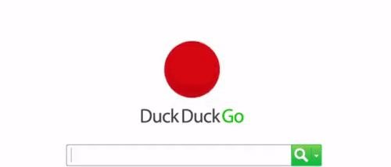

Application dedicated

to **search** information on World Wide Web



ACTIVITY

# 5 MIN Activity 1



* On your browser go to either Bing or Google search engine



* Search for the following information

|  |
| --- |
| What is the capital of CHILE |

How many countries in the world

What is the difference between HAVE TO and MUST HAVE

## HOMEWORK

Homework



• **Read** the handout

• **Answer** the questions

